Claude for enterprise - HIPPA ready offering
Implementation Guide for HIPPA Entities
Source for the following content: PDF from Anthropic Trust Center
You may download your copy from https://trust.anthropic.com/ using your corporate email id.
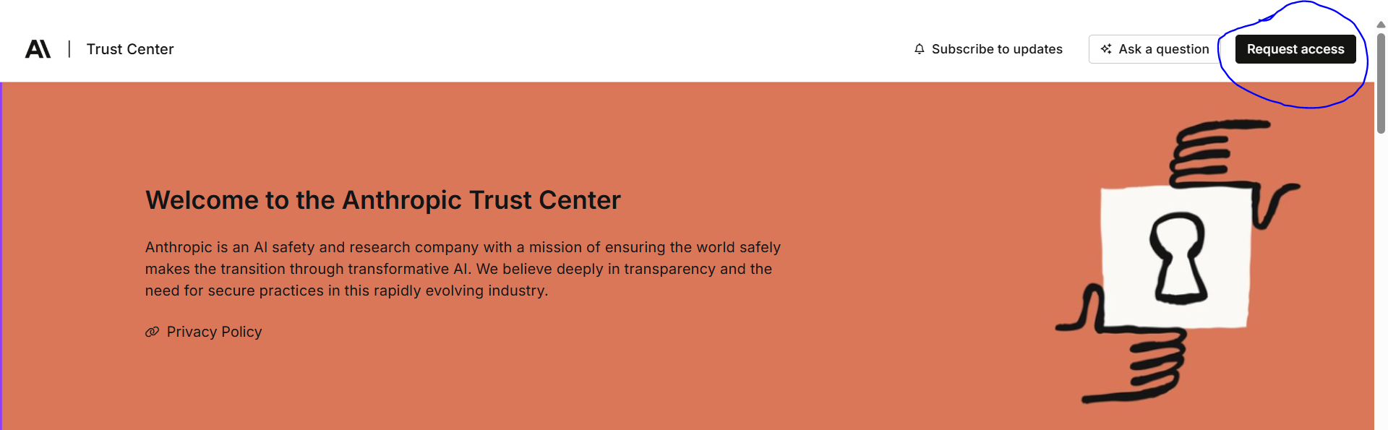

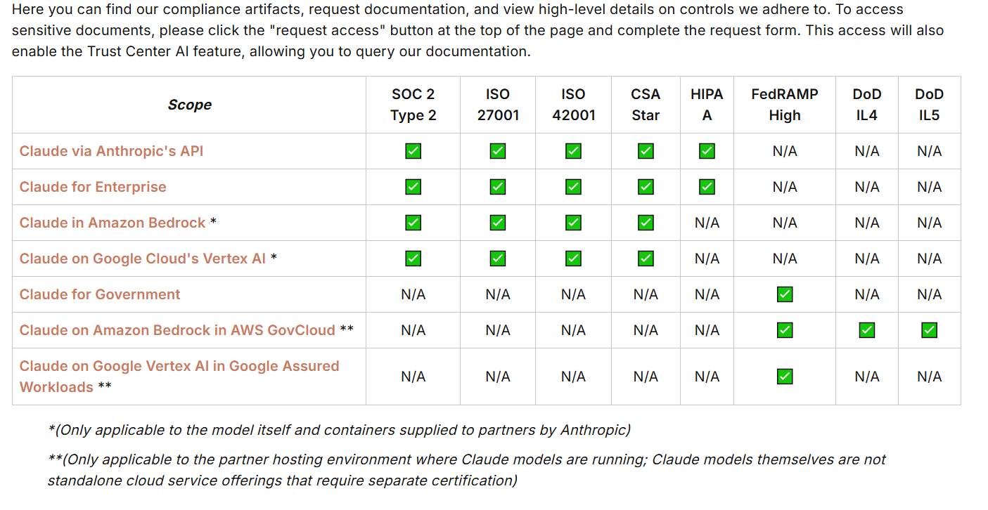

Claude’s HIPPA ready offering covers only eligible services: (under BAA)
- Anthropic’s native API with Zero Data Retention enabled.
- Web and app-based access to HIPPA-Ready Claude for Enterprise - Chat

Models supporting the eligible services:
- Haiku
- Sonnet
- Opus

For example, if you purchase HIPPA-Ready Claude for Enterprise as part of a bundle, certain services that may be part of the bundle (Like Claude Code seats) but not part for Eligible services.

The eligible services are designed for enterprise collaboration only.
Patients, plan members, or their families or employers may not be added as users or guests to any anthropic teams, projects, workspaces, artifacts or other anthropic service that can be accessed by individuals outside your organization.

Third Party Integrations:
Integration like, MCP servers, connectors, desktop extensions, skills, plugins - If such third party integrations outside of Anthropic’s services platform are subject to third party’s terms, policies and controls. Compliance regarding such integrations will fall within the organization's administrators obligations and not Anthropic.

Enterprise Search:
Can be integrated to search organization’s project repository, including commonly used connectors for documents and chats like slack, microsoft 365, sharepoint, google drive and more. Only connectors that administrators enables will be available in the enterprise search.
Anthropic Has not entered into BAA or Sub BAA with such third party connectors available via enterprise search; however these third parties may offer their own HIPPA eligible services that may be available through connectors.

Configurations:

Audit logs and data loss prevention tools: Anthropic provides a compliance API to support monitoring of access, activity, and data entered into your own tools and processes for monitoring your users use of the Eligible services, including potential integration of DLP tool for enforcement of message and file restrictions and export.

Train your workforce to the appropriate use of the Eligible services including handling of PHI.

You can integrate third party tools including those featured in these listings, however the use of those third party integrations is not covered under BAA with Anthropic.

It is your responsibility to determine whether a BAA between your organization and any third party is appropriate and if so for you to handle execution of such BAA directly with such third party.

Once data has been shared with or accessed by such third party tools, it may be subject to that third party’s privacy policy, terms or other agreements.

Please download your copy with more detailed information on other necessary requirements and actions from the resources section by requesting access.
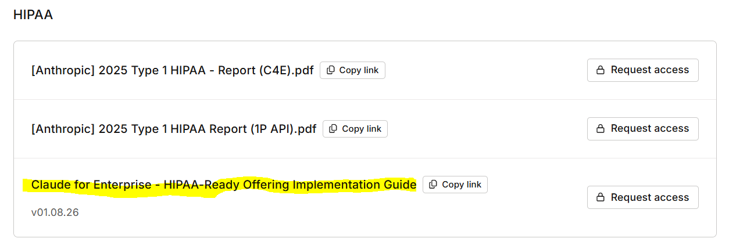

https://ai.azure.com/catalog/models

The latest Claude models displayed on the Azure foundry Catalogue are the following:
Claude Opus 4.5
Version: 20251101
https://ai.azure.com/catalog/models/claude-opus-4-5

About this model
Claude Opus 4.5 is Anthropic’s most intelligent model, and an industry leader across coding, agents, computer use, and enterprise workflows.

Key model capabilities
- Extended thinking: Extended thinking gives Claude enhanced reasoning capabilities for complex tasks.
- Image & text input: With strong vision capabilities, Claude Opus 4.5 can process images and return text outputs to analyze and understand charts, graphs, technical diagrams, reports, and other visual assets.
- Computer use: Claude Opus 4.5 is Anthropic’s most accurate model for computer use, enabling developers to direct Claude to use computers the way people do.
- Advanced tool use: Build agents that can take action with three new capabilities–the tool search tool, programmatic tool calling, and tool use examples.

Claude Haiku 4.5
Version: 20251001
https://ai.azure.com/catalog/models/claude-haiku-4-5

About this model
Claude Haiku 4.5 delivers near-frontier performance for a wide range of use cases, and stands out as one of the best coding and agent models–with the right speed and cost to power free products and scaled sub-agents.

Key model capabilities
- Extended thinking: Extended thinking gives Claude enhanced reasoning capabilities for complex tasks.
- Image & text input: Claude Haiku 4.5 can process images and return text outputs to analyze and understand charts, graphs, technical diagrams, reports, and other visual assets.

Claude Sonnet 4.5
Version: 20250929
https://ai.azure.com/catalog/models/claude-sonnet-4-5

About this model
Claude Sonnet 4.5 is Anthropic's most capable model to date for building real-world agents and handling complex, long-horizon tasks, balancing the right speed and cost for high-volume use cases.

Key model capabilities
- Extended thinking: Extended thinking gives Claude enhanced reasoning capabilities for complex tasks.
- Image & text input: With strong vision capabilities, Claude Sonnet 4.5 can process images and return text outputs to analyze and understand charts, graphs, technical diagrams, reports, and other visual assets.
- Computer use: Claude Sonnet 4.5 is Anthropic's most accurate model for computer use, enabling developers to direct Claude to use computers the way people do.

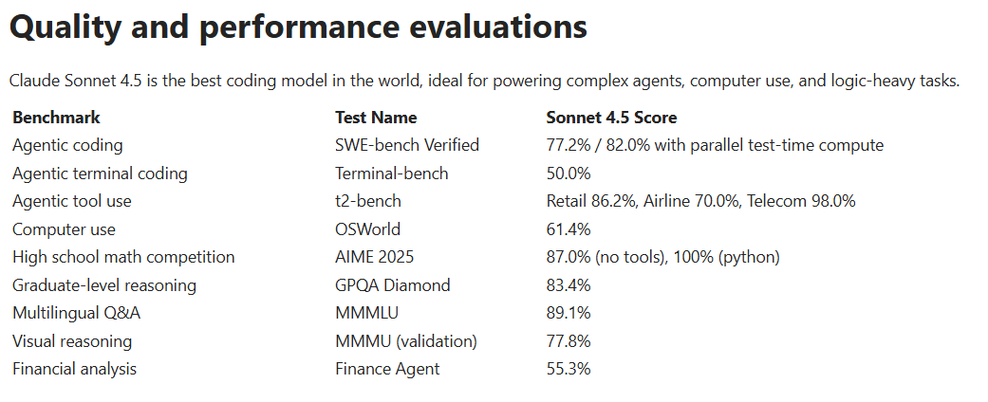

Other references:
https://assets.anthropic.com/m/12f214efcc2f457a/original/Claude-Sonnet-4-5-System-Card.pdf

Skills we can leverage:

Document Processing:

https://github.com/K-Dense-AI/claude-scientific-skills/blob/main/scientific-skills/document-skills/docx/SKILL.md
https://github.com/anthropics/skills/tree/main/skills/pdf

Many skills under:
https://github.com/K-Dense-AI/claude-scientific-skills/tree/main/scientific-skills

Can explore more.

Unable to test this on free claude mode:
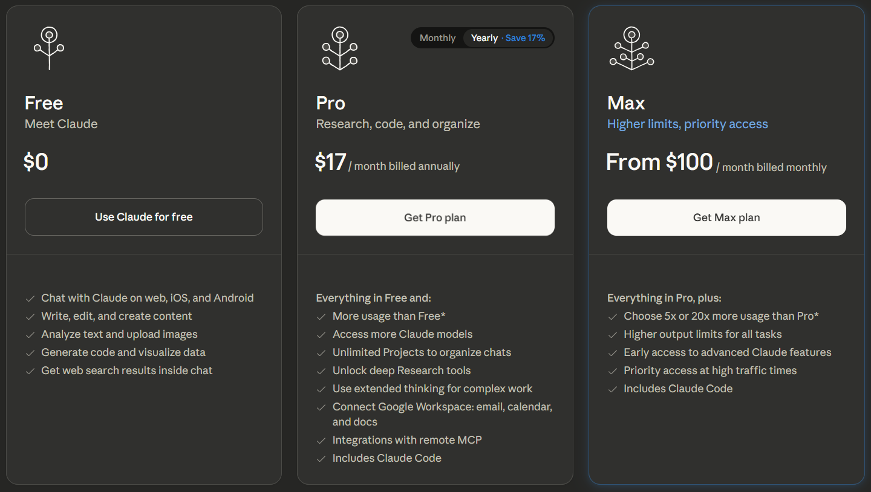

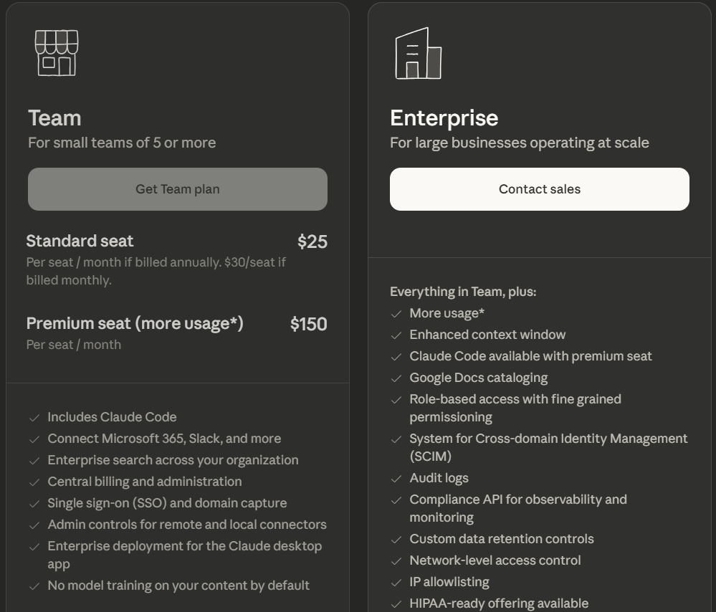

Claude on Microsoft Foundry:
youtube.com/watch?v=HCY-VoJHaFA
https://www.youtube.com/watch?v=C6rxEGJay70
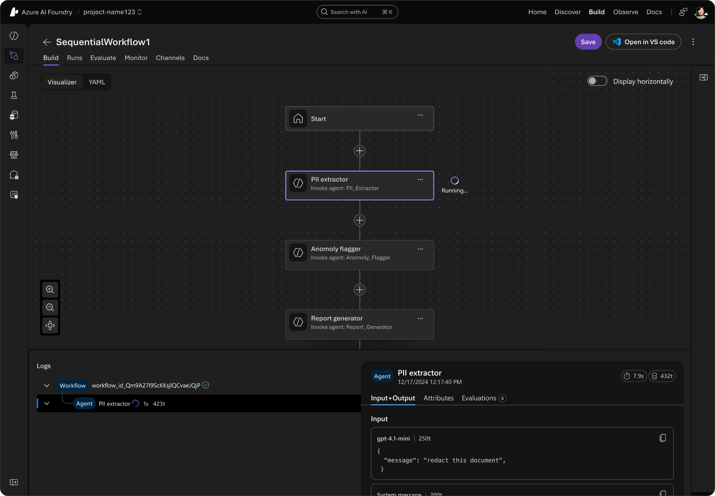
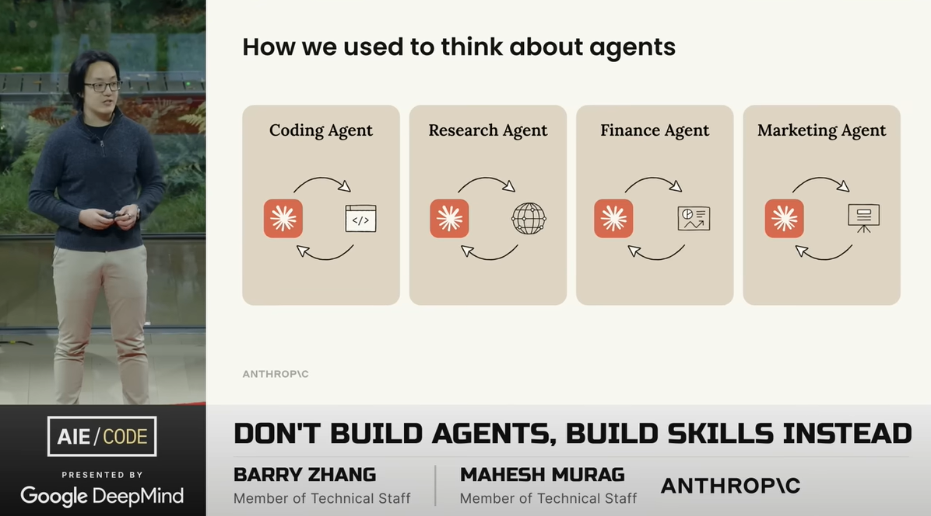

Skill repositories: https://medium.com/@frulouis/25-top-claude-agent-skills-registries-community-collections-you-should-know-2025-52aab45c877d

Claude converses with Neo4j via MCP:
https://neo4j.com/blog/developer/claude-converses-neo4j-via-mcp/
https://github.com/ma3u/neo4j-agentframework/blob/main/CLAUDE.md
https://towardsdatascience.com/using-claude-skills-with-neo4j/
Claude Neo4j Blueprints:
https://github.com/SNRose07/claude-neo4j-blueprint/blob/feature/blueprint-foundation/docs/TASK5_1_BUSINESS_RELATIONSHIPS_VALIDATION_SUMMARY.md
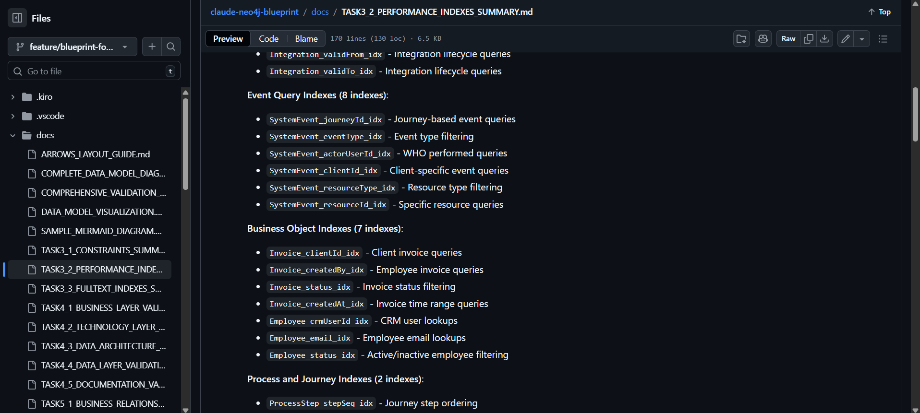

Claude NetworkX Skills:
https://github.com/K-Dense-AI/claude-scientific-skills/blob/main/scientific-skills/networkx/SKILL.md
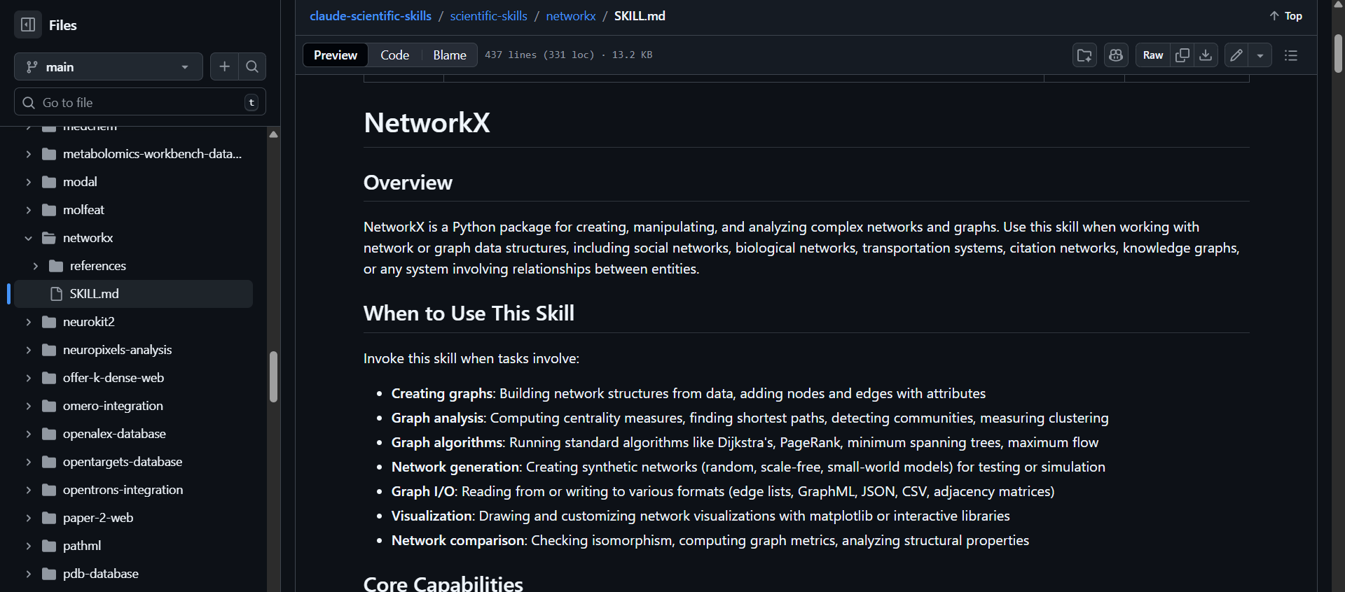

Claude Concept | Azure AI Foundry Equivalent
Skill | Prompt Flow node
Skill chaining | Prompt Flow DAG
Skill inputs/outputs | Typed flow parameters
Agent orchestration | Prompt Flow orchestration
Skill state | Flow context / memory store
Tool calling | Functions / APIs / Logic Apps

Skills are usually configured in Claude Code:

https://www.nathanonn.com/claude-skills-part-2-how-to-turn-your-battle-tested-code-into-a-reusable-superpower/
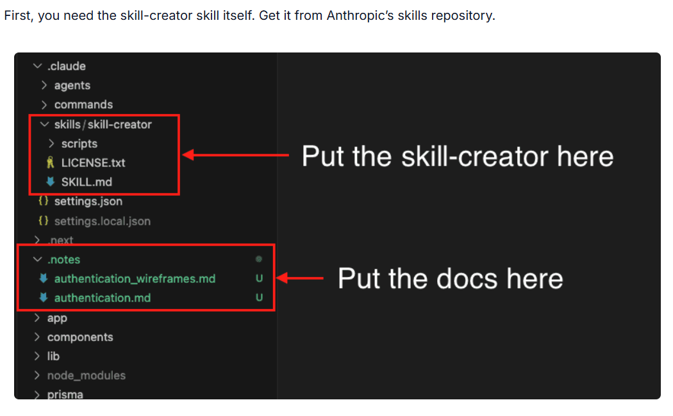

Other References:

https://www.anthropic.com/news/healthcare-life-sciences
https://claude.com/solutions/healthcare
https://www.microsoft.com/en-us/industry/blog/healthcare/2026/01/11/bridging-the-gap-between-ai-and-medicine-claude-in-microsoft-foundry-advances-capabilities-for-healthcare-and-life-sciences-customers/

Some skills to explore:
https://github.com/K-Dense-AI/claude-scientific-skills/tree/main/scientific-skills/clinical-reports
https://github.com/K-Dense-AI/claude-scientific-skills/tree/main/scientific-skills/fda-database
https://github.com/K-Dense-AI/claude-scientific-skills/tree/main/scientific-skills/pubmed-database
https://github.com/K-Dense-AI/claude-scientific-skills/blob/main/scientific-skills/pyhealth/SKILL.md

